Rincon Aynoa
Professor Jerri A. Harwell
ENGL 2010- (Position/proposal)
31 March 2016
Armed Conflict and Children
Almost every day we hear of children suffering violence all around the world. There are millions of families who are living in an oppressive government, which kills young people for no reason. I know about this from my personal experience. I lived in an oppressive government and I was a victim of armed conflict. In 2014 I was almost shot with a gun just because I thought different from the “others” who tried to kill my mom a few seconds before they tried to do so with me. I did not do anything wrong, I just was in the wrong place, at the wrong time. This is an experience I will never forget. I know this is just minimum compared with other people’s situations around the world. Sadly, most of them are children who like me, have experienced armed conflict and it has left them a huge impression that will never be forgotten.
Young people have faced violent experiences that either you or I cannot ever imagine. Or way worse, those children have lost their entire families, and innocence in armed conflicts. These tragedies have been caused by men in power without considering what effects these actions could have on children. Armed conflicts have had an enormous impact in children’s life throughout the years. Because of the huge social context in which an armed conflict take place, we have to analyze several factors simultaneously, such as: Children’s health and social development, military spending and recruiting children soldiers. We will be able to see the impact of war in a child’s life.
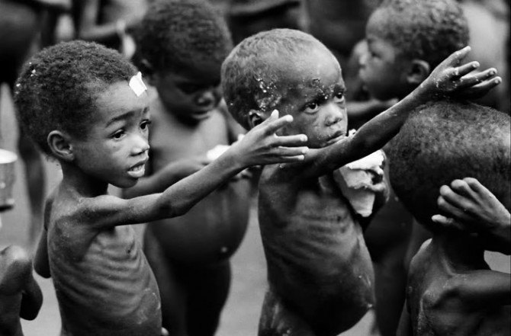
According to Steve Carlton Ford, Children under the age of five respond rapidly to major social changes. Also, he states that “young children under the age of five have one of the highest war-related mortality rate of any age group” (Carlton-ford). This statistic is pretty surprising, because this age group is the most vulnerable in hard times. But, this problem goes further in war’s effect on children. Malnourishment and illness are other plagues that come in war times. When a country is in conflict, the economy shuts down. There is no trade or commercialization, as a result of the unavailability of food in the country. Therefore, this reflects rapidly on a child. “Mental health and psychosocial well-being in settings of armed conflict are threatened by exposure to violence and other risk factors for mental health such as increased poverty and lack of access to basic services for example healthcare, education, housing, water, and sanitation, most conflicts take place principally in lower middle income countries” (Jordans). Also, this shows the instability of the government and its inability to defend future generations of the country. On the other hand, the limitations of the government or enterprises to build better infrastructures can lead to an environmental problem or, contamination of water. Giving as a result no adequate sanitary facilities, and spreading of viruses like diarrhea and many others.
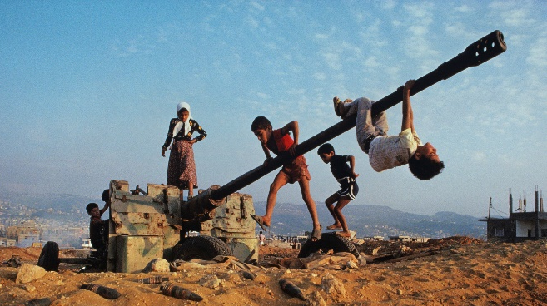
On the contrary, many governments focus their attention on the armies and national welfare in conflict times. “A series of studies show that as countries devote more of their wealth to arms imports, their national economic weaken, food become less available, and children’s nutrition suffers” (Carlton-ford). Although, it is important to say that military spending does not tend to harm young children, the misuse of scarce funds intended for more beneficial uses, does. Leaders, in some cases, will prefer to use national resources in military actions, instead of using it to provide basic means for quality of life to the nation (water, food, services).
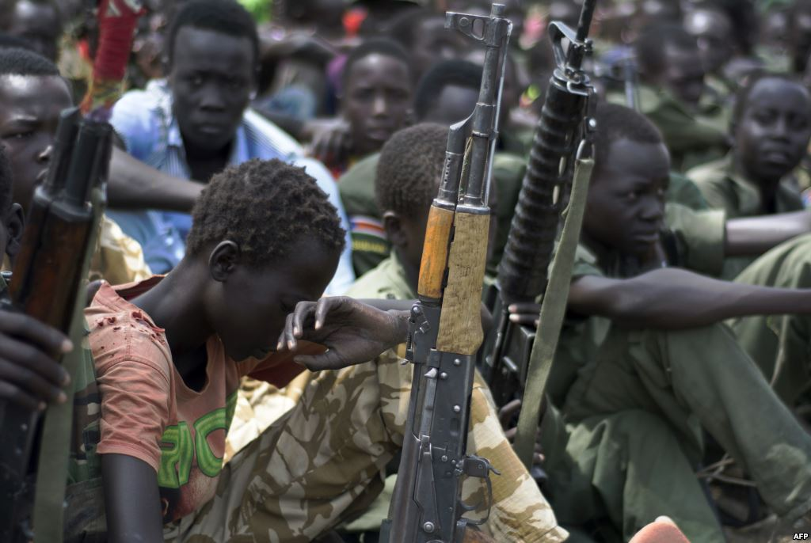
An armed conflict “…led to growing numbers of children leaving school to work, marrying young or joining armed groups, as way as supporting their families financially” (Laub). According to Lynne O’Donnell in his article UN condemns use of child soldiers in Afghanistan, he states that armed groups had been recruiting young people since the 1990’s. “They are not going to school; they are deprived to access health. They are targeted by armed groups and they are prevented from having hope from the future” (O’Donnell). In most of the cases, majority of these children are taken against their will from their houses and made to join these forces under the threat of having their families murdered. In other cases, “recruitment was mainly driven by poverty, but also filial duty, patriotism and honor” (O’Donnell). In this specific case, armed troops in the Middle East are religious extremists and appeal to these young children by their morals and values, but their recruitment offerings change drastically once they are inside the armed group or when they already recruited. Most of these “soldiers” are deprived of the minimum basic rights.
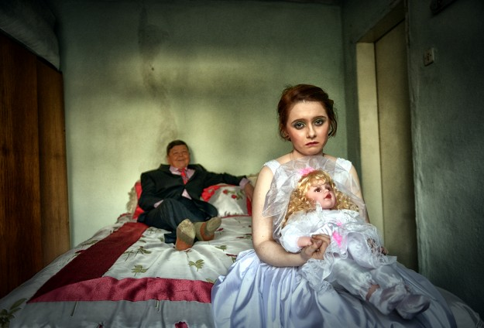
Other impact or armed conflict is in human development. Basically, marriage and fertility become a hard labor for young women in armed conflicts. “Young women in conflict-affected regions are at risk of a number of adverse outcomes as a result of violence, economic deterioration and the breakdown of community structures and services” (Neal). Issues like violence, economic conditions and poor access to services make a family and personal relations harder for some girls. It is important to mention that in some areas such as Mid East countries girls tend to have arranged marriages, (10-17 years.). On the other hand, marriage has increased for girls under 18 years old. “Early marriages provided protection for young women against premarital pregnancy” (Neal). On contrary, many of marriages for young women in refugee’s camps were arranged by parents, mostly with older men and seen as a way of financial security for their daughters. Mostly in this countries, many girls have entered into the marriage earlier than normal (07-09 years) in response to the reduce availability of male partners (Neal). Reduction of a male figure has become normal for families in armed conflict situations. Parents had lost their lives in war or most of them had migrated out of the country seeking for better opportunities. In many war countries we find that orphans and wives have the most rapidly increasing rate numbers.
Armed conflicts have negative effects in children’s wellbeing. It also, interferes with peer relations. Decreasing in schooling, cause children to not interact with each other. In some cases, it can create isolation. In addition, the hard situation they are going through and the misunderstanding about what is happening in their lives. These children represent the future, one which will have to be re-built after all the damage made by previous generations (fathers, grandfathers).
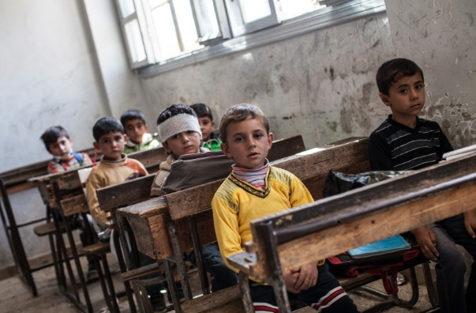
Life chances decrease when a child is in a war country. The longer the war, the more damage to the society and economy. One of the biggest problems in war is the high levels of debt. After a war, the upcoming generation will be responsible for paying this debt. “A country at war has fewer and fewer economic resources to devote to maintaining the health and well-being of its people” (Carlton-Ford). Our children will not have the privilege of a free life, they will owe every single coin to international lenders. This, goes completely against children’s human rights. Just as was the case during the civil war years in the US, no children of a slave would have the right to be free or pursuit happiness. Children in war conflict will be destined forever to be in the same place and paying for something they did not do.
In opposition to children’s rights, journalist called Stephen Kindzer has a different view about human rights in general and how they should be applied. According to Kindzer,“In some cases (Human Rights Watch), their work, far from saving lives, actually causes more death, more repression, more brutality and an absolute weakening of human rights.” His main idea about Human rights international organizations is basically that they are not transparent enough and they do not spread true peace on earth, on the contrary, they create more damage in society. Human Rights Watch (HRW), United nations among others, just follows a “western based ideas” and “the west has a providential right to intervene wherever in the world it wishes” (Kindzer). He feels, human rights organizations are “a movement opposing to human rights” and all these movements are to get westerns a military victory in front of developing countries. The idea of winning cases in a court rather than in the battlefield is on the main basis Kindzer uses to justify his point, and also that sometimes these International organizations do not study their cases as deep as they should. He states “The question should not be whether a particular leader or regime violates western-conceived standards of human rights. Instead, it should be whether a leader or regime, in totality, is making life better or worse for ordinary people” (Kindzer). With this quote he takes a position against international organizations, and he moves towards those countries who had the intervention of organizations when they have armed conflicts.
War countries and their leaders do not take in count the immense consequences of this problem to their citizens, especially when they take the decision to start an armed conflict. This affects the common denominator in society enormously. “These conflicts take place principally in lower and middle-income countries, where 90 % of the world’s population of children and adolescents live” (Jordans). Most children in the world live in developing countries, where they are more exposed to war and armed conflicts.
I propose that we should prevent this conflicts to happen in future to begin with by educate, improve access to food and encouraging international organizations to advocate their mission. We, as a raising generation should not use violence to solve conflicts. Also, in most cases this conflict affects always external people. Those who are not linked to what is happening. We have to educate children into realizing the only solution is not what they are seeing, war and violence. There are other ways to channel and overcome problems and conflicts. Humans talk and no fight.
Second, for those countries in need of help to improve access to food, water and basic services for armies and citizens alike, they should be prepared for war as well as for improving defenses in times of peace but without leaving the common citizen out. In improving common routes and saving resources they could have a better outcome out of war. It is known that a country in war is a country uncommunicated and dangerous. But if we foresee the scenario of the conflict getting harder, we can provide a “better life” for a child, since none of them deserves to live in these conditions. We should probably consider not all are as lucky as American children who have their basic needs for life covered and better life chances as a result. It is because of this we have to at least preserve minimum conditions for children at war elsewhere.
Thirdly, indulging into considering the validity of what Stephen Kindzer said. International Organizations should advocate their mission to help these kind of countries, not causing more damage or conflicts among them. Also, they should probably leave out all the “unnecessary” propaganda and make a true effort towards acting. This is not a television show. This is real life and those children’s lives are in danger because of someone else’s doing. These organizations have the chance to help children and bring them back to life. A life that is normal and one a common child deserves. Play on the ground, go to the park, and eat ice cream in a hot sunny day. Going to school and playing with their friends. These and more are activities that all children should be able to enjoy. These should be their only responsibilities, and these activities are their “training” to in a not too far away future, melt into society. If you damage this stage in a child, you are wrecking their entire stages to come.
I can testify myself that armed conflicts are not a safe environment for children. I remember my mom’s expression every single day before going to bed and I can just think of those millions of children who are going to bed every night without knowing if they are going to wake up. Or, if they are going to see their parents again at the end of the day After this experience I believe that there is not a more painful experience than not having any rights to pursue your happiness because other’s actions. I remember a famous quote from Mahatma Gandhi that says ““An eye for an eye will only make the whole world blind.” I firmly believe that violence and conflicts are not going to take us anywhere. This actions will just damage our society more and more every day. Is this the heritage we want for our children? A world full of chaos, hate and resentment. This should not happen anymore. I decided that I’m going to work hard to be an ambassador in the United Nations, to defend those children and work for guarantee human rights around the world. Those children, who once like me, have faced violence from external situations. Or way worse, those children who had lost their parents and their innocence in war. One you lose your innocence; it is gone forever.

Works Cited
Carlton-Ford, Steve. "Armed Conflict and Children's Life Chances." Peace Review 16.2 (2004): 185. TOPICsearch. Web. 22 Mar. 2016.
Jordans, Mark J. D., Hugo Pigott, and Wietse A. Tol. "Interventions for Children Affected by Armed Conflict: A Systematic Review of Mental Health and Psychosocial Support in Low- and Middle-Income Countries." Current Psychiatry Reports Curr Psychiatry Rep 18.1 (2016): n. pag. Web. 19 Mar. 2016.
Kinzer, Stephen. "End Human Rights Imperialism Now." www.guardian.co.uk. 2010. Rpt. in Human Rights. Ed. David M. Haugen and Susan Musser. Detroit: Greenhaven Press, 2013. Opposing Viewpoints. Opposing Viewpoints in Context. Web. 22 Mar. 2016.
Laub Karin - Associated, Press. "UNICEF: More Than 80 Percent Of Syria Children Harmed By War." AP Top News Package (2016): Points of View Reference Center. Web. 22 Mar. 2016
Neal, Sarah, Nicole Stone, and Roger Ingham. "The Impact Of Armed Conflict On Adolescent Transitions: A Systematic Review Of Quantitative Research On Age Of Sexual Debut, First Marriage And First Birth In Young Women Under The Age Of 20 Years." BMC Public Health 16.(2016): 1-11 11p. CINAHL Complete. Web. 22 Mar. 2016.
O'Donnell Lynne - Associated, Press. "UN Condemns Use Of Child Soldiers In Afghanistan." AP English Worldstream - English (2016): Points of View Reference Center. Web. 22 Mar. 2016.

